April 6, 2021 Contact: Sherry Poland, Director
FOR IMMEDIATE RELEASE Sally Krisel, Deputy Director

VAX & VOTE: UNIQUE OPPORTUNITY FOR HAMILTON COUNTY VOTERS

The Hamilton County Board of Elections (BOE) and Hamilton County Public Health are sharing space at the Board’s voting annex, 2300 Wall Street in Norwood. This combination offers voters – who have an appointment for their vaccination in Norwood – an opportunity to also take advantage of early voting!

The Tuesday, May 4, 2021 Primary/Special is open for voters who live in:
City of Cincinnati Non-Partisan Mayoral Primary & Charter Amendments
City of Harrison Republican Primary
Village of Silverton Democratic Primary & Tax Levy
Deer Park Tax Levy
North College Hill Tax Levy
Indian Hill Sch District Bond Issue
Winton Woods Sch District Tax Levy

“We have been vaccinating residents at 2300 Wall Street for several months, and appreciate our collaboration with the Board of Elections,” said Greg Kesterman, Commissioner of Hamilton County Public Health. “This combination of resources is a win-win for the taxpayers in Hamilton County.”

“Early voting for the May Primary/Special began today,” according to Sherry Poland, Director of the BOE. In this unprecedented time, we are looking for creative ways to make voting accessible to all voters. And encourage residents to VAX & VOTE!”

Hours for early voting:
April 6-April 23rd, 8am-5pm, Monday thru Friday
This expands April 26-April 30th to 8am-7pm, Monday thru Friday
Saturday May 1, 8am-4pm
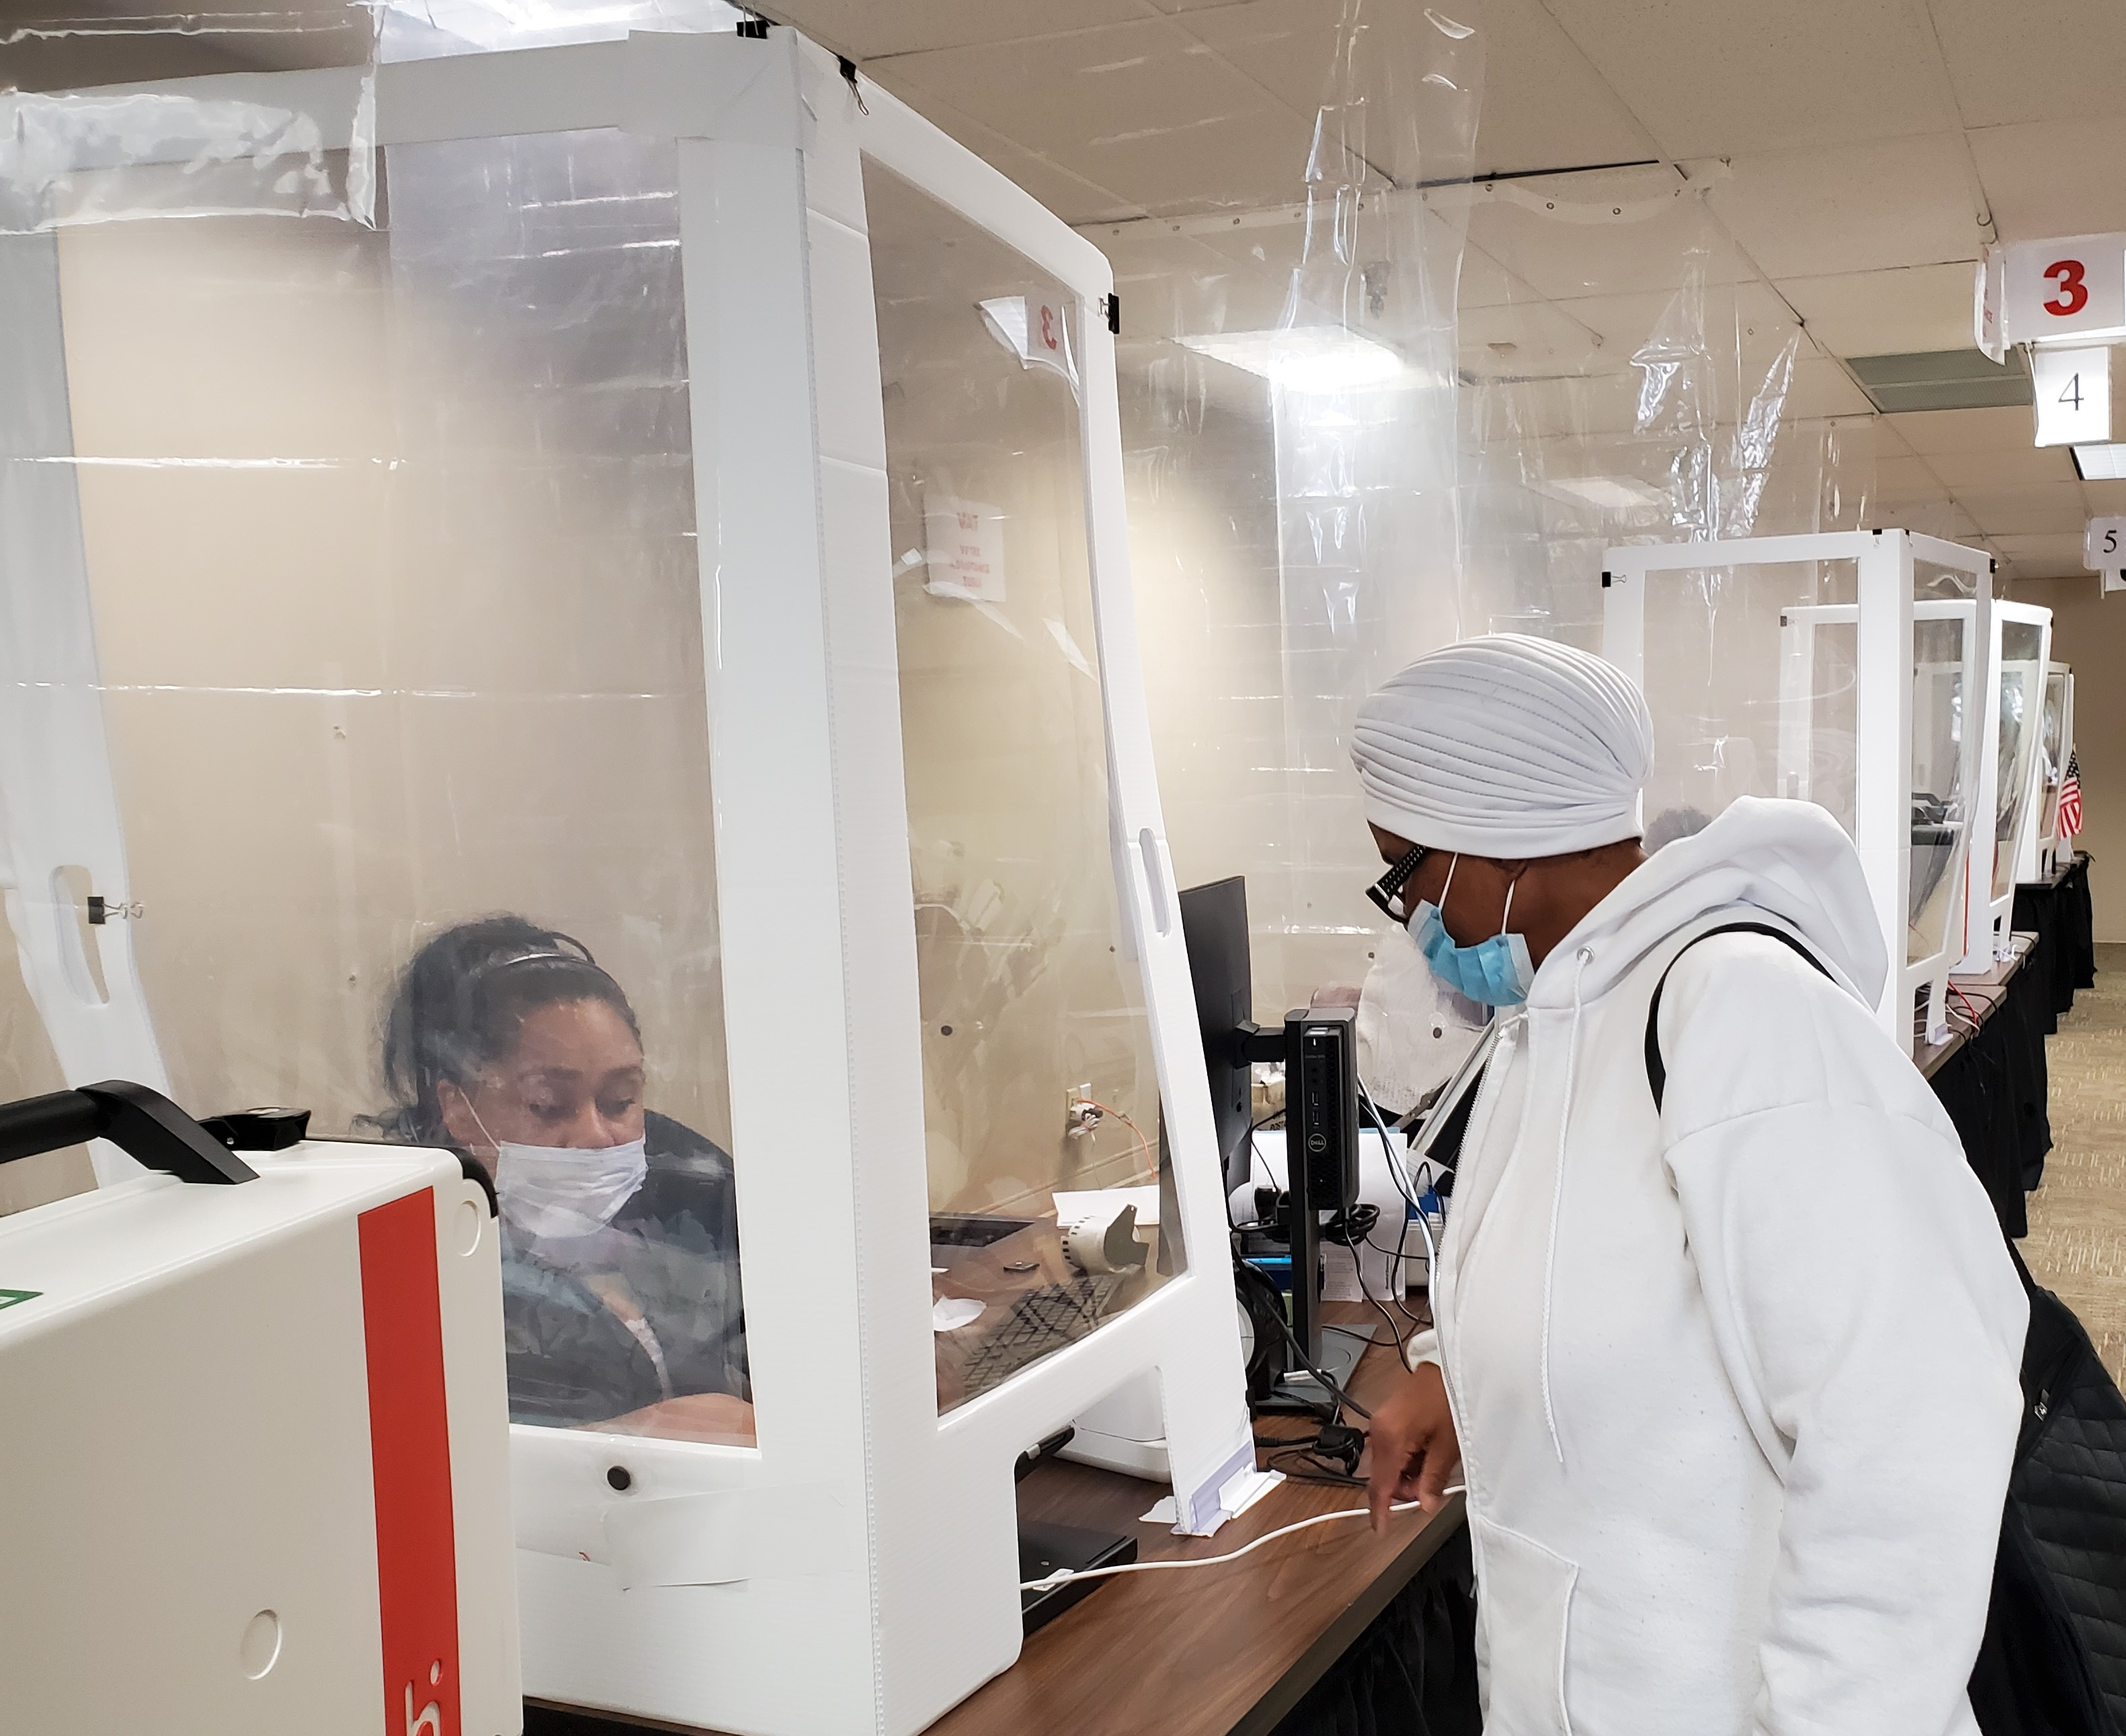
Sunday May 2, 1-5pm
Monday, May 3, 8am-2pm
Follow all the latest BOE news and Info on Facebook, Twitter, Instagram, and website: votehamiltoncountyohio.gov
For Info to set up a vaccination visit: www.hcph.org

